Evelyn Sjafii, ID: 914017341

Alicia Siu, ID: 914005515

ECS174 Computer Vision

June 4, 2019

Problem Set 3: Bag of Visual Words

***Part I. Short Answer Problems***

1. What exactly does the value recorded in a single dimension of a SIFT keypoint descriptor signify?

***Answer:*** The value represents the magnitude of one of the 8 gradient directions. The SIFT keypoint descriptor has dimension of 128 because each SIFT descriptor consists of 8 gradient directions in a 4x4 bin (4x4x8 = 128). The following image is from: <https://www.oreilly.com/library/view/computer-vision-with/9781788299763/f3a93025-1f6c-47db-a76d-6e73d06328a4.xhtml>



2. A deep neural network has multiple layers with non-linear activation functions (e.g., ReLU) in between each layer, which allows it to learn a complex non-linear function. Suppose instead we had a deep neural network without any non-linear activation functions. Concisely describe what effect this would have on the network. (Hint: can it still be considered a deep network?)

***Answer:***  If instead we had a deep neural network without any non-linear activation functions, this neural network would be calculating linear combinations of linear functions. In other words, if we had a linear function, and we applied a layer, the result would still be a linear function. No matter how many layers are applied, the output would still be a linear function and hence, the neural network cannot learn. The non-linear functions, on the other hand, will generate different non-linear models, and continue to allow the network to learn more complex functions.

***Part II: Programming Problem – video search with bag of visual words***

**1. Raw descriptor matching**

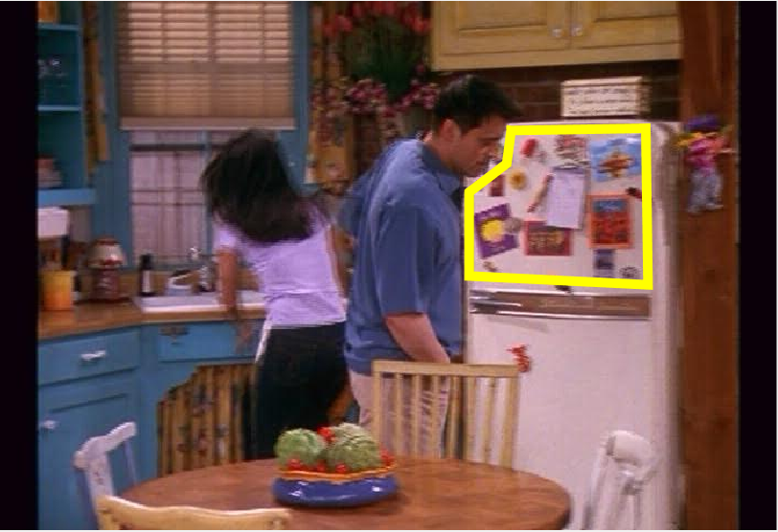

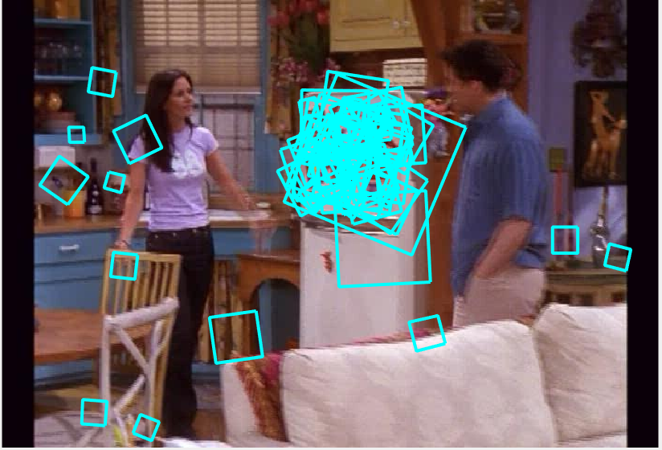

**2. Visualizing vocabulary**

The results below show two different visual words with 25 patches displayed. We can see that the patches associated with each visual word have similar patterns. Using k-means, we clustered descriptors of similar or same features together. Each cluster represents a visual word. We chose two of these clusters/words and displayed 25 descriptors in each cluster. This results in the similarity of some of the patches shown below.

*Visual Word #1:*

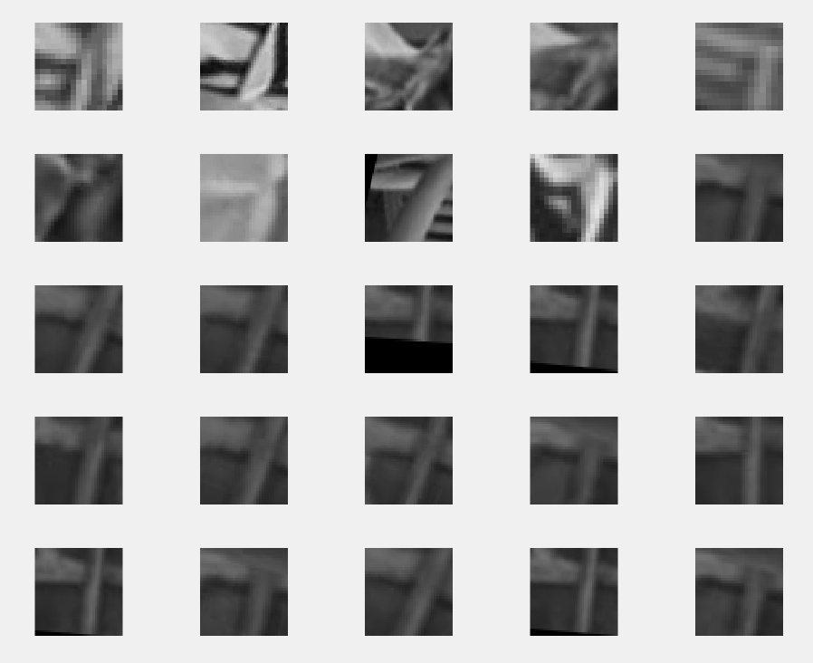

*Visual Word #2:*

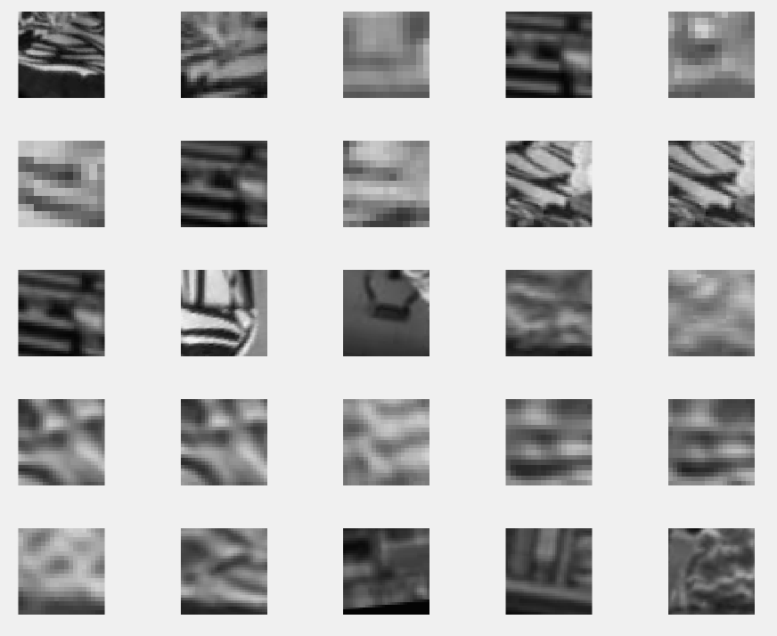

**3. Full frame queries**

The results below show the chosen query frame on the top-left corner and the other 5 are the most similar frames. We can see that these frames are chosen because the features in each frame are very similar to one another. Features such as the faces, clothes, or objects like the teacup, drawers or things in the cabinet shelves all help to determine which frames are similar.

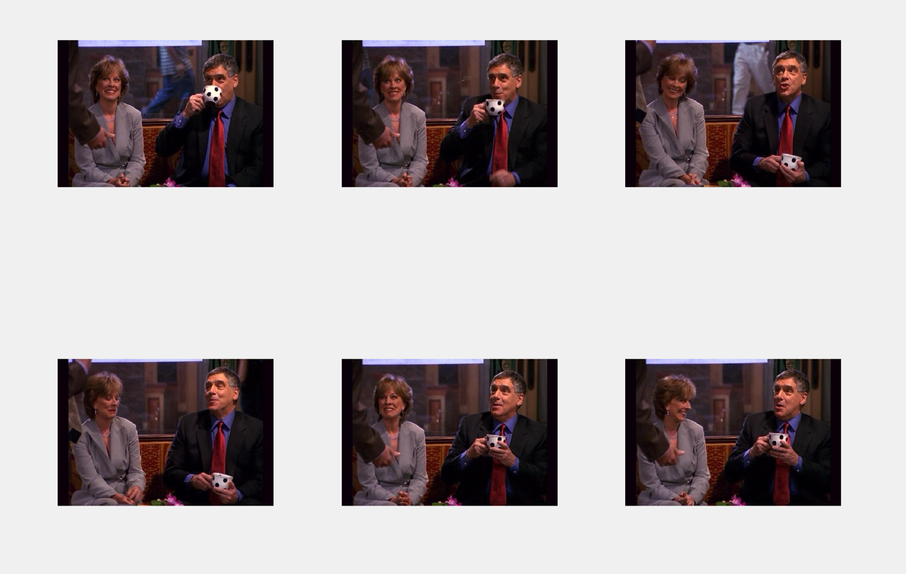

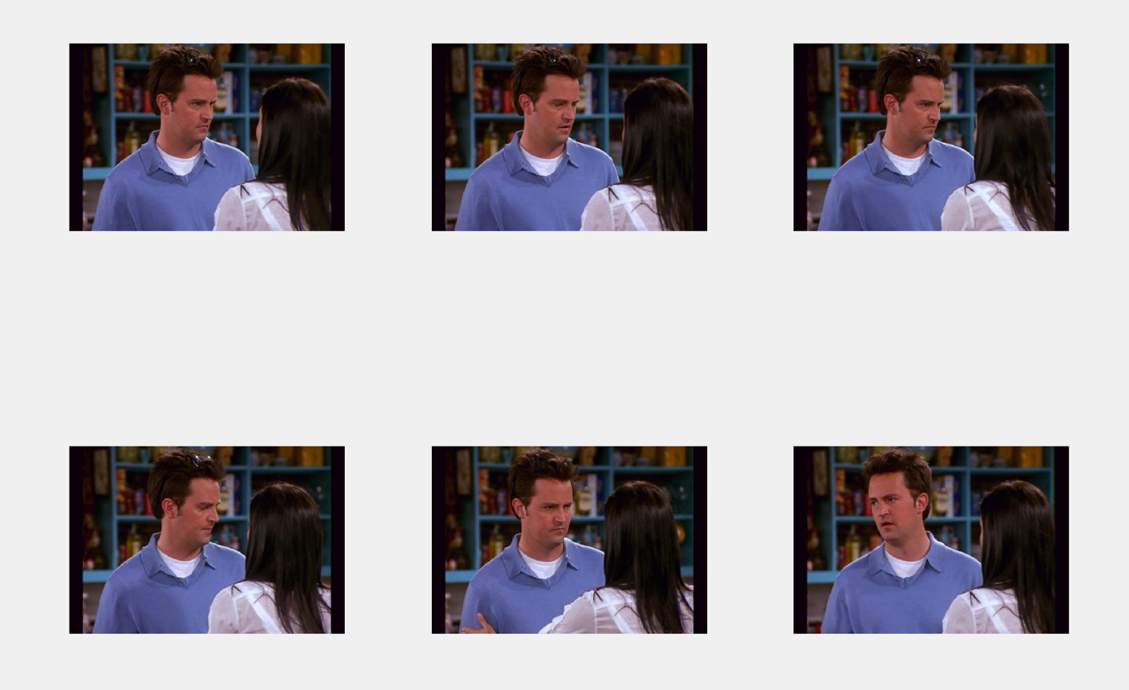

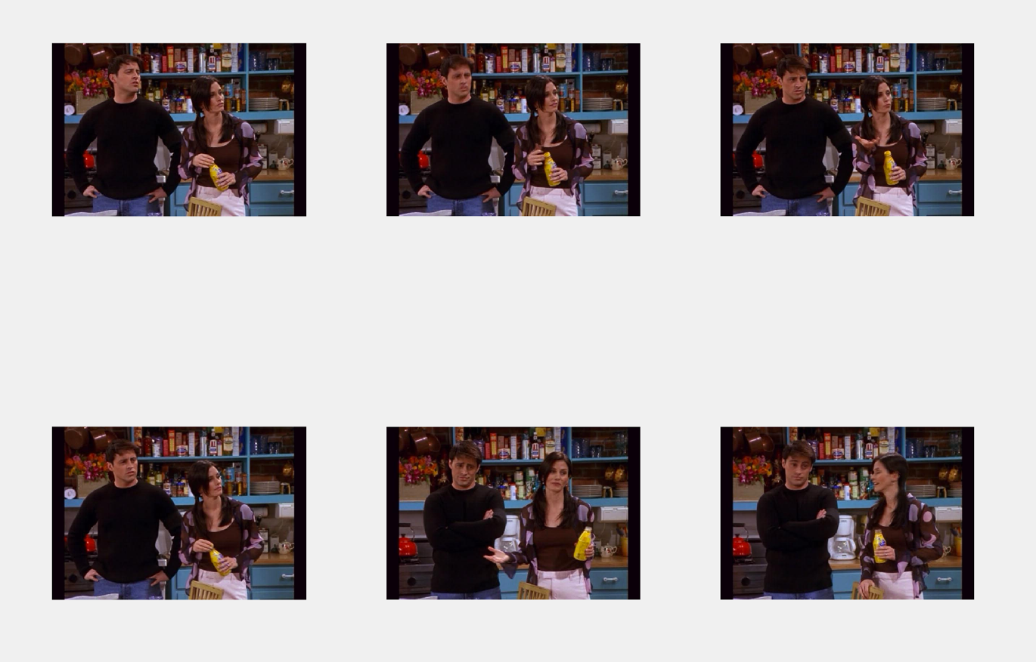

**4. Region queries**

The results below show the chosen query frame with the selected region of interest (indicated by the yellow polygon) on the top-left corner and the other 5 frames are the retrieved frames with the same object present in each frame.

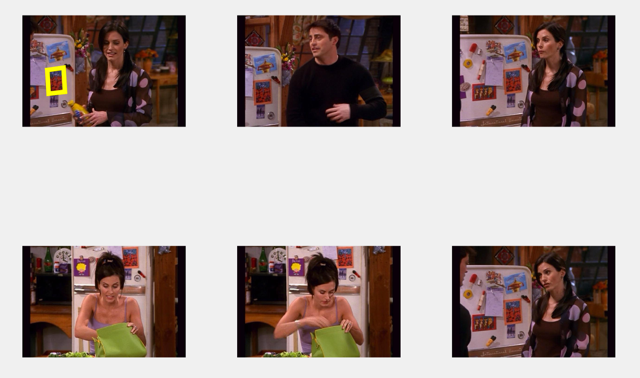

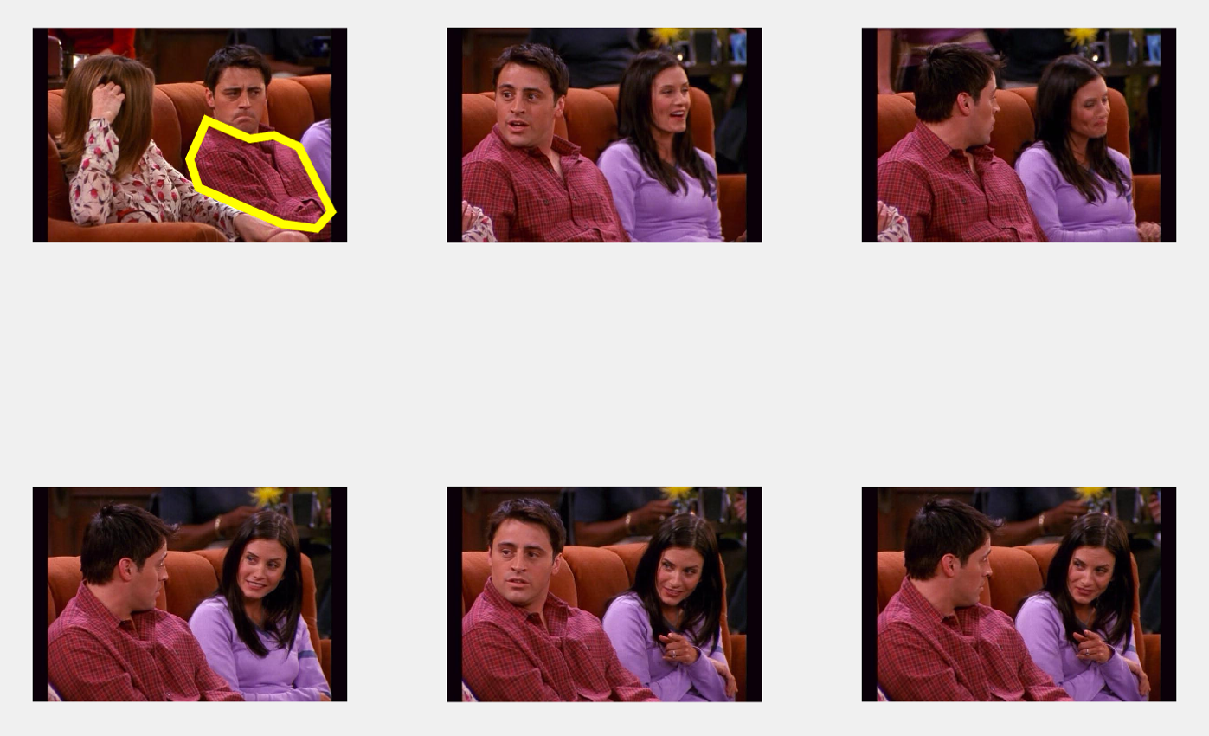

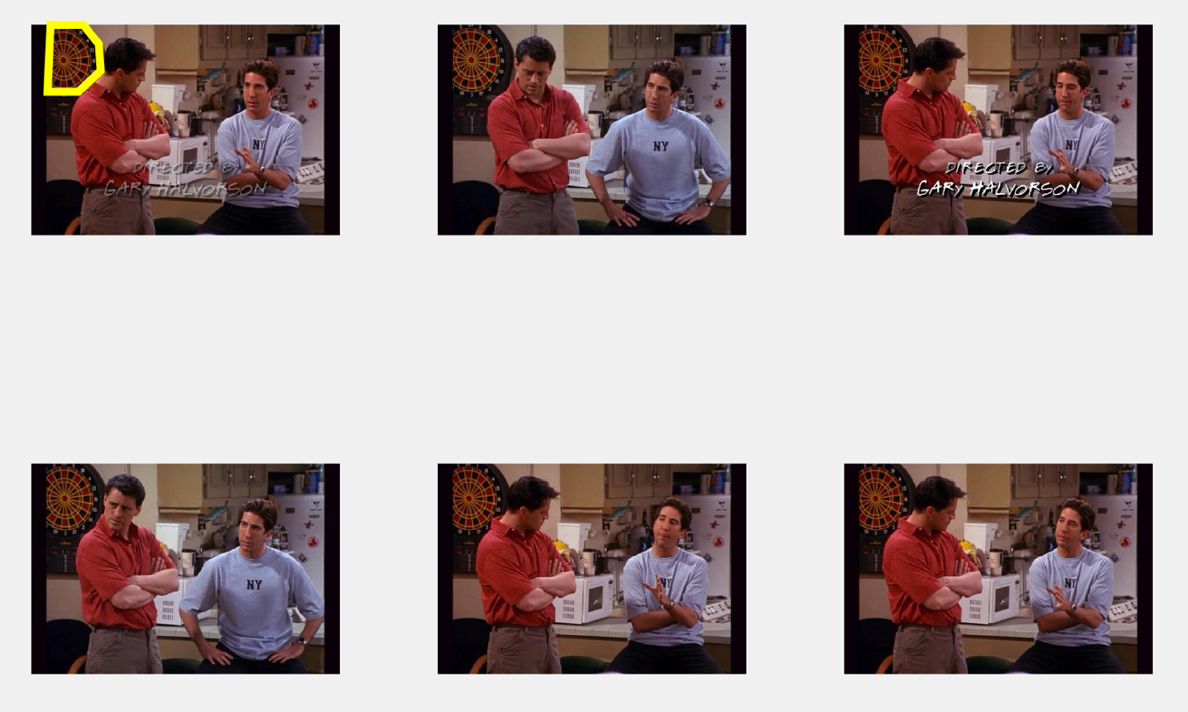

**FAILURE CASE:**

This case is a failure case because the 5 frames are different from the chosen query frame. The problem with this case is that even though the highlighted region of interest is the lady’s face, it is mistaken as other people’s faces. This method cannot distinguish the difference in facial features of different people, so one person’s face can be mistakenly considered very similar to another person’s face.

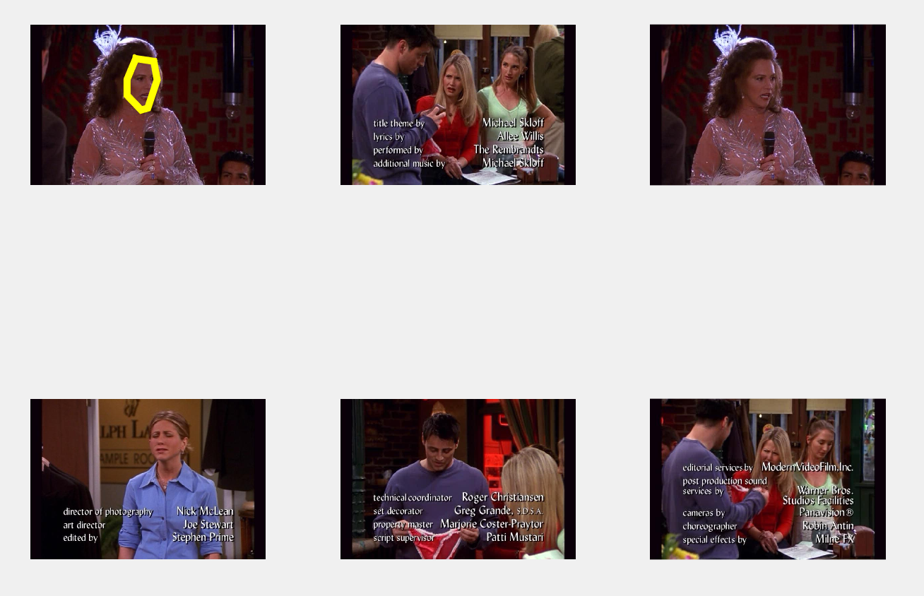

**5. Comparing SIFT bag-of-words with Deep Features**

From the comparison of results shown below, we can see that the results using bag of words histograms are not quite successful because the frames are quite different from each other. For example, in the first set of frames, the images of the singing lady are confused with images with lights or white spots in the background.

The results using AlexNet is clearly more successful in extracting frames that are similar to the query frame. In the first set of frames, the singing lady is again chosen as the query frame, but this time the 10 other frames are very similar. The singing lady is present in all the frames and the features in each frame resemble one another very closely. This is similar to the second set of frames using AlexNet.

Using AlexNet gives much better results than bag of words because it takes into account the context of each image. Bag of words simply compares each feature with features of other frames in isolation, ignoring the contextual aspect. Since AlexNet is a neural network, it involves layers of feature extraction and learns high-level features from images. Feature and image classification with AlexNet is more advanced and creates more accurate results compared to bag of words.

* **With bag of words histograms**

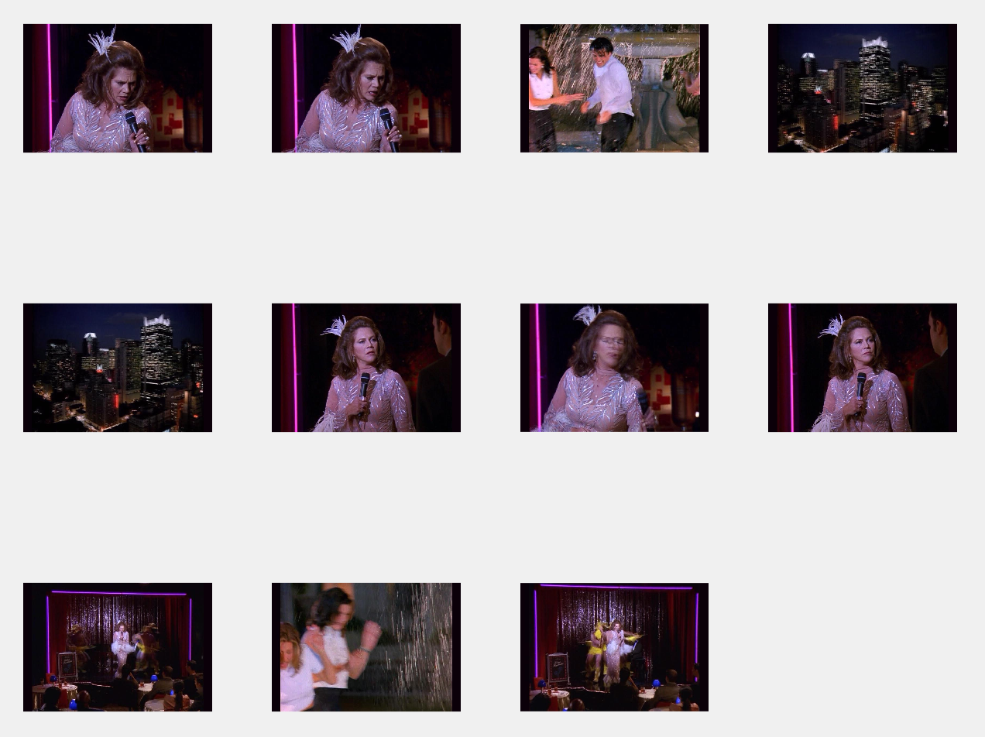

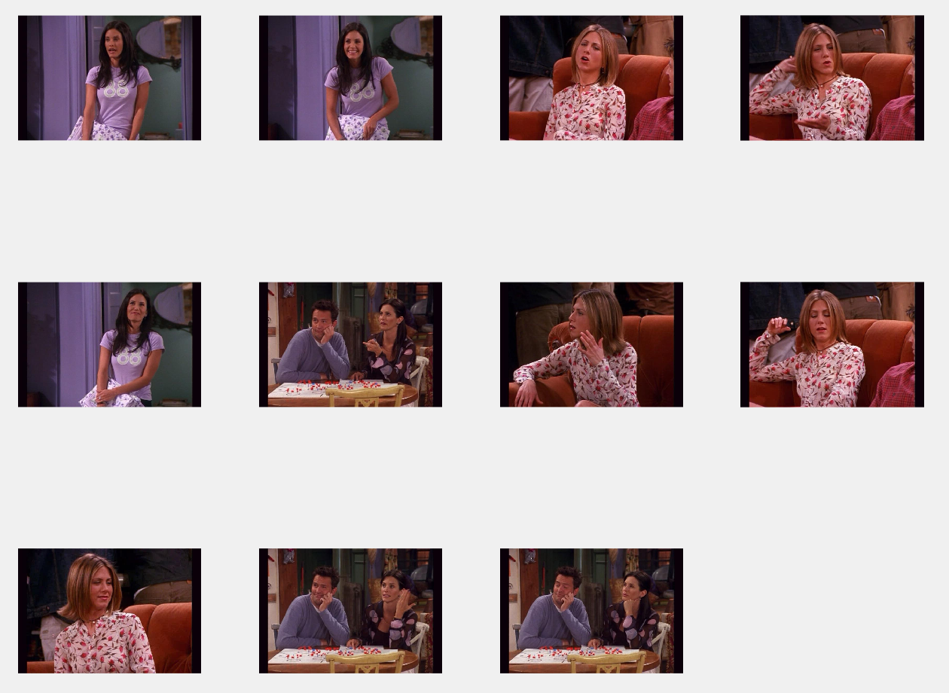

* **With AlexNet**

